Dutch Accreditation Council (RvA)

English example Calibration Certificate
Document code: | RvA-I2.22-UK
 | Version 2, 20-4-2016

RvA information documents describe the RvA rules and its policy on specific subjects. A current version of the information documents is available through the RvA web site (www.rva.nl).

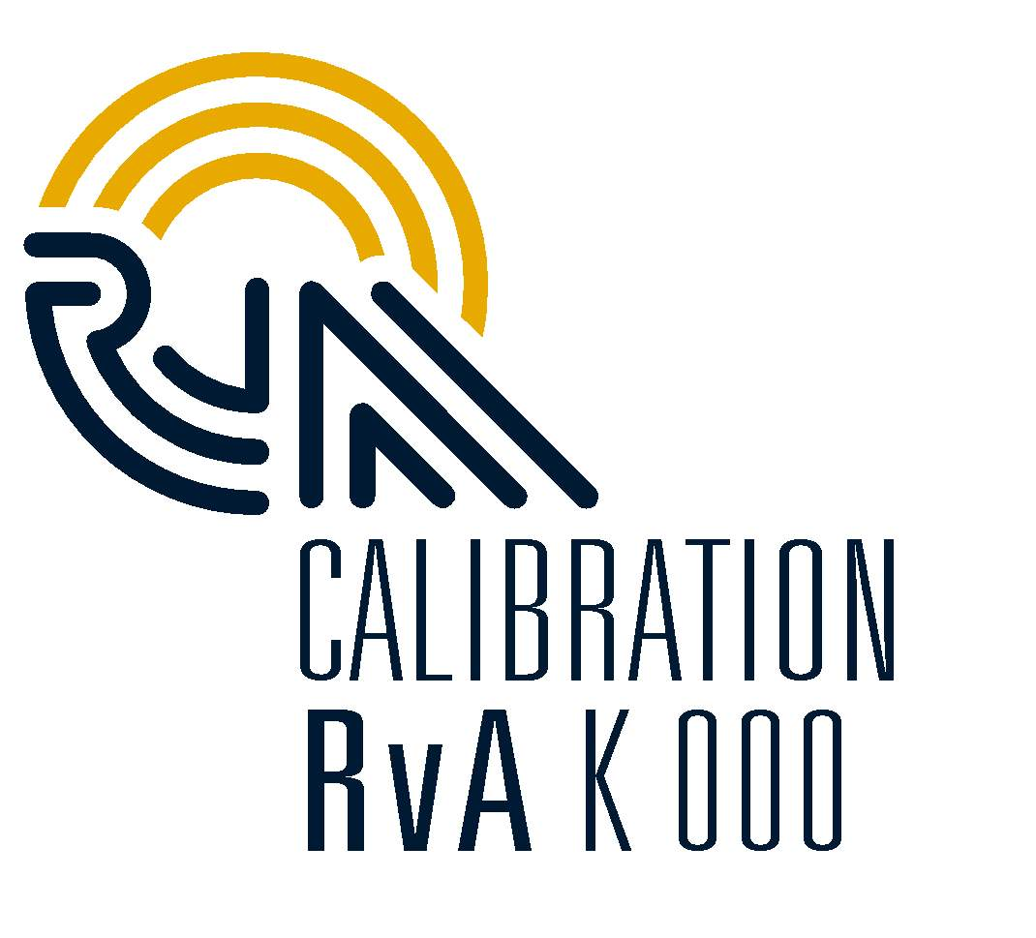English example certificate

Name and logo
of the accredited lab.

CALIBRATION CERTIFICATE

Page .. of .. certificate number: unique

Applicant: unique identification of customer
Instrument: unique identification
Manufacturer:
Type:
Serial number:

calibration method: Brief explanation of method or reference to publicly available document (standard).

environmental conditions:
date of calibration/
period of calibration:

results: may be stated on following pages, possible combined with uncertainties

uncertainty: The reported expanded uncertainty is based on the standard uncertainty of the measurement multiplied by a coverage factor k, such that the coverage probability corresponds to approximately 95%.
The standard uncertainty has been determined in accordance with EA 04/2.

Traceability: The measurements have been executed using standards for which the traceability to (inter) national standards has been demonstrated towards the RvA.

Date:

name (signatory)
function (for example Technical Cal. Manager)
Address of Laboratory | RvA is member of the European Co-operation for Accreditation (EA) and is one of the signatories to the EA Multilateral Agreement (MLA) and to the ILAC Mutual Recognition Arrangement (MRA) for the mutual recognition of calibration certificates. | Reproduction of the complete certificate is allowed. Parts of the certificate may only be produced with written approval of the calibration laboratory.  This certificate is issued provided that the Raad voor Accreditatie does not assume any liability.

